Emergency Wheelchair Distribution
Event Venue | Bhaktapur Hospital
Event Date: | 1st August 2026
Details | As part of its commitment to Community Health and Humanitarian Service, the Rotary Club of Bhaktapur provided essential mobility support to patients at Bhaktapur Hospital. On 1st August 2026, the club handed over three wheelchairs to the Emergency Department of Bhaktapur Hospital to support patients requiring immediate mobility assistance.  The wheelchairs were provided to strengthen patient support within the Emergency Department, particularly for patients who face difficulty walking or require assistance while being transferred within the hospital premises.  Through this initiative, the Rotary Club of Bhaktapur contributed a practical and essential resource to the hospital, supporting improved accessibility, patient care, and dignity.
Specialty | - Handover of 3 wheelchairs to Bhaktapur Hospital Emergency Department.  • Provided essential mobility support for patients requiring assistance.  • Supported improved accessibility within the hospital's emergency services.  • Strengthened Rotary's contribution to community healthcare.  • Addressed a practical and immediate need within the hospital.
Facts & Figures | Date: 1st August 2026  • Venue: Bhaktapur Hospital – Emergency Department  • Activity: Wheelchair Handover  • Wheelchairs Provided: 3  • Project Focus: Community Health & Humanitarian Service
Budget | - Cost per Wheelchair: NPR 5,000  - Total Budget: NPR 15,000/
Beneficiary Profile | - Patients visiting the Emergency Department of Bhaktapur Hospital.  • Patients with mobility challenges requiring wheelchair assistance.  • Hospital staff supporting patient movement and emergency care.
Impact/Outcome | Improved mobility and accessibility for patients requiring assistance.  • Supported safer and more convenient movement of patients within the Emergency Department.  • Enhanced the hospital's capacity to provide immediate mobility assistance.  • Contributed to patient dignity and comfort during emergency care.  • Demonstrated Rotary Club of Bhaktapur's commitment to supporting local healthcare institutions and community needs.

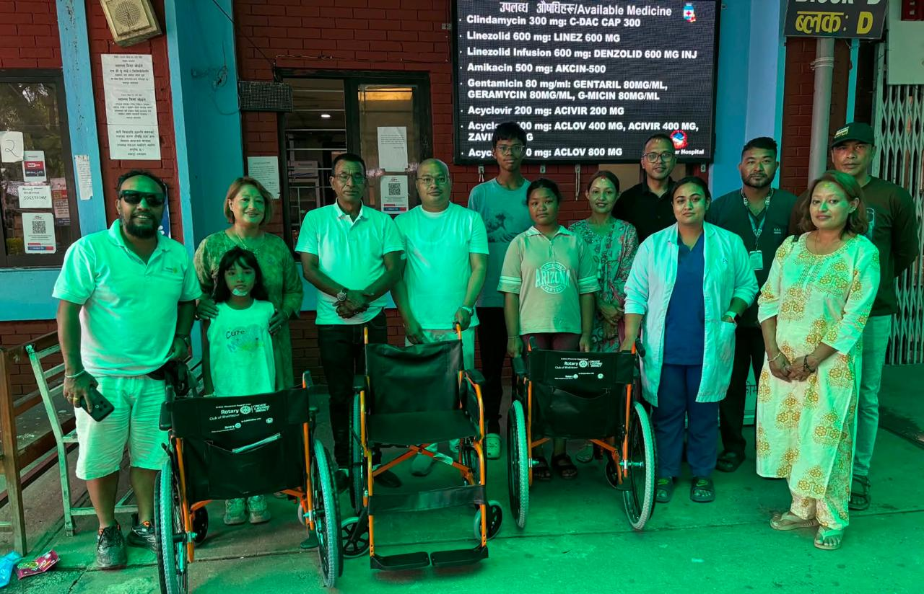
Kindly find the pictures below:

Submitted by :
Rtn. Dasrath Prajapati Rtn. Priyanka Chaguthi
President RY 2026/27 Secretary RY 2026/27

