Rotary Club of Dhulikhel
Service Project Report for the month of June – July 2026
Club News and Activities

Title (4-7 Words): | Building Sustainable Livelihoods through Coffee Farmers Training
Club Name: | Rotary Club of Dhulikhel
Event Date: | 28th June 2026
News (100-250words)  - Specialty  - Facts & Figures  - Budget  - Beneficiary Profile  - Impact/Outcome | The Rotary Club of Dhulikhel, in collaboration with RCC Namobuddha, organized a Coffee Farmers Training Program to enhance the knowledge and skills of local coffee growers through practical and technical education. The training was facilitated by renowned coffee expert Dr. Bhola Kumar Shrestha, focusing on sustainable coffee cultivation, plantation management, pest and disease control, post-harvest processing, quality improvement, and market opportunities.  The program was conducted in Namobuddha Municipality–7, Kavrepalanchok, with the participation of 40 coffee farmers and 10 RCC members. Approximately 180 -200 family members benefited indirectly from the improved knowledge and practices shared during the training. The sessions covered modern coffee farming techniques, intercropping, sustainable agricultural practices.  The project was implemented with an estimated budget of NPR 125,000. The primary beneficiaries were smallholder coffee farmers from rural communities, including women and youth engaged in agriculture.  The initiative reflects Rotary’s commitment to Community and Economic Development by promoting sustainable income generation and resilient farming communities.
Do not write/edit/correct anything on shaded space and attach picture separately.

Written by: Rtn. Nilopher Shrestha
Checked & approved by: Rtn Mohan Kumar Shrestha
Submitted by: Rtn. Nilopher Shrestha
Date: 31 July 2026
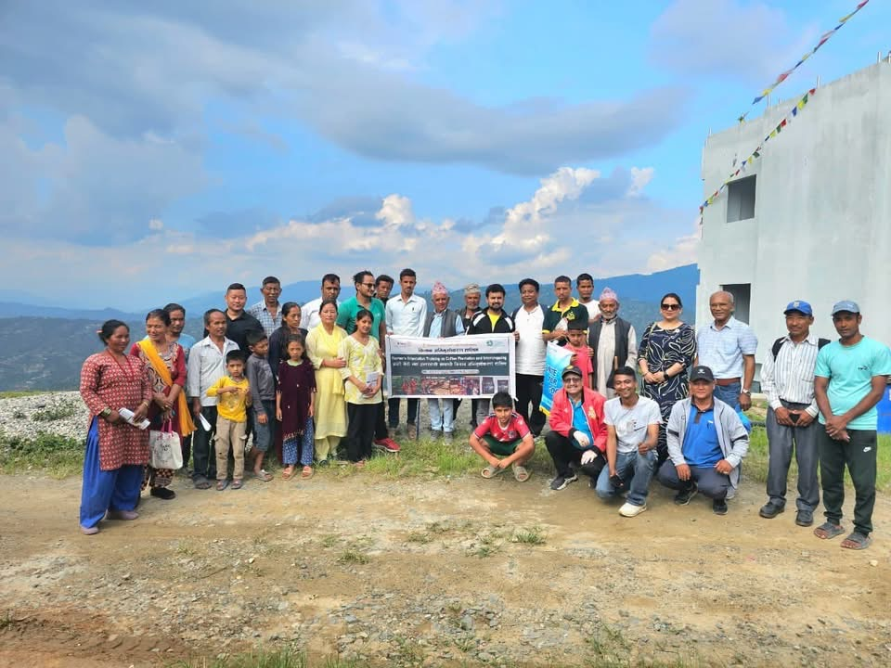
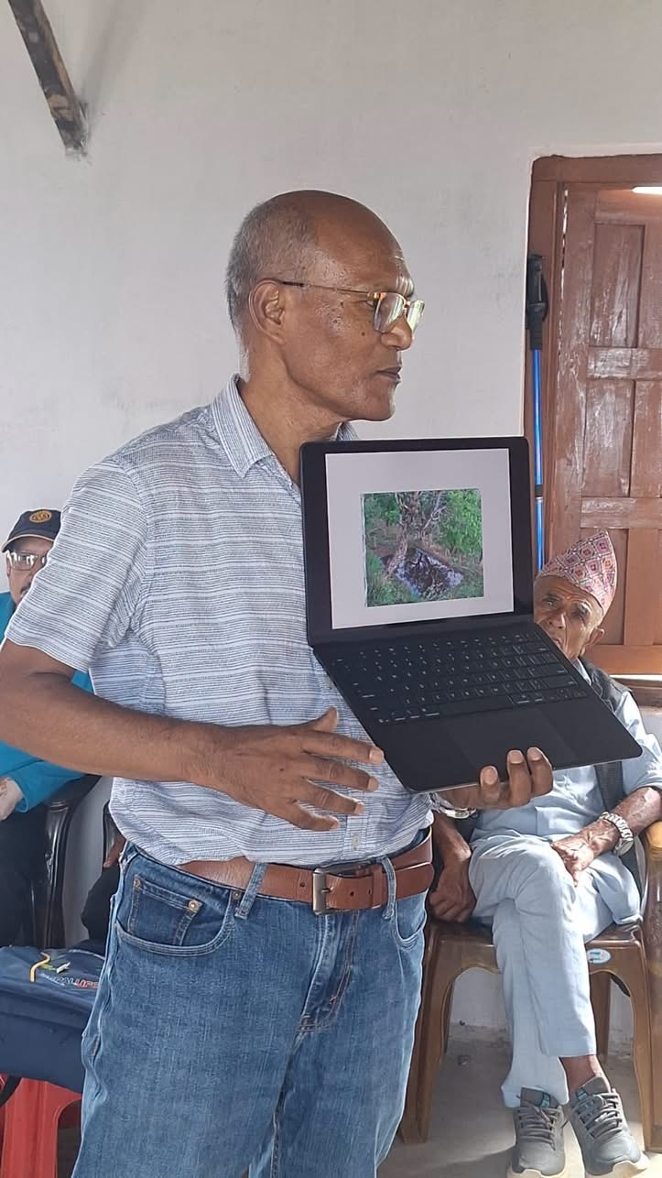
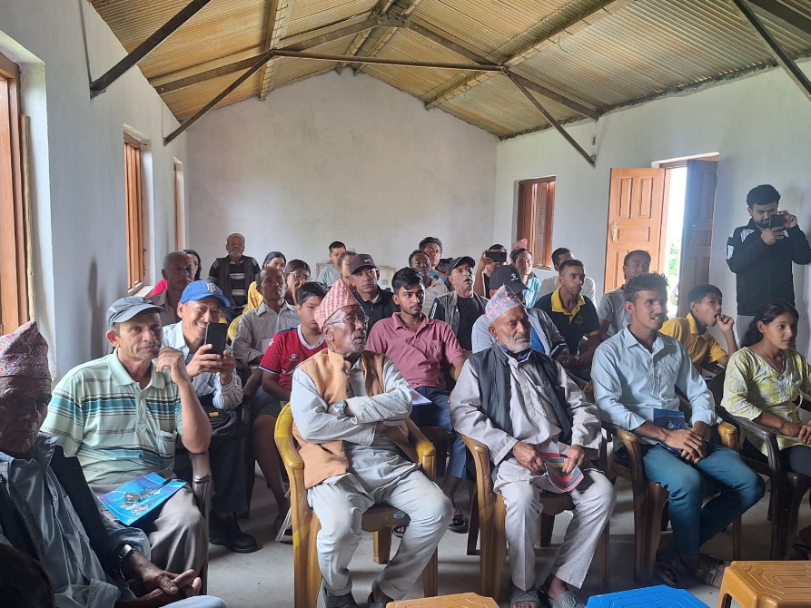

Do not write/edit/correct anything on shaded space and attach picture separately.

Written by: Rtn. Nilopher Shrestha
Checked & approved by: Rtn Mohan Kumar Shrestha
Submitted by: Rtn. Nilopher Shrestha
Date: 31 July 2026

