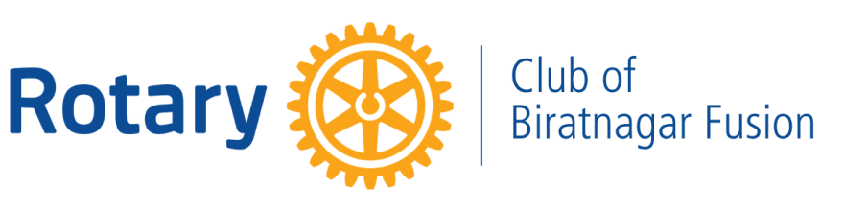

SERVICE PROJECT REPORT
FREE EYE SCREENING CAMP

Rotary Year | 2026–27
Date | 25 August 2026
Location | Budiganga Gaupalika, Morang
Area of Focus | Disease Prevention and Treatment
Joint Project With | Rotary Club of Biratnagar Gemini
In Collaboration With | Ramlal Golchha Eye Hospital
Prepared by | Rtn. Aparna Nathani, Secretary

Project Overview
Rotary Club of Biratnagar Fusion organized a Free Eye Screening Camp as a joint service project with its sponsored club, Rotary Club of Biratnagar Gemini, in collaboration with Ramlal Golchha Eye Hospital.
The project was undertaken with the objective of improving access to essential eye-care services and creating awareness about the importance of early detection and timely treatment of eye-related conditions among residents of Budiganga Gaupalika, Morang.
The initiative went beyond general eye examination by also incorporating diabetic retinopathy screening and identifying patients requiring further medical intervention, particularly cataract treatment.

Objective of the Project
The primary objective was to take preventive eye-care services closer to the community and encourage individuals to undergo timely eye examinations.
Through awareness, screening and referral for further treatment, the project aimed to identify eye-related problems at an early stage and help prevent avoidable deterioration of vision.

Project Reach & Implementation
The outreach programme covered 7 wards of Budiganga Gaupalika. Eye-health information and awareness were disseminated to approximately 1,800 people, extending the impact of the initiative beyond those who were physically screened at the camp.
During the programme, 194 patients underwent eye screening. The screening included general eye examination as well as diabetic retinopathy screening, helping identify individuals requiring further evaluation or treatment.
Patients diagnosed with cataract and requiring surgical intervention were identified and guided towards further treatment in coordination with the collaborating eye hospital.

Facts & Figures
Particulars | Achievement
People Reached through Eye-Health Awareness | Approx. 1,800
Patients Screened | 194
Cataract Patients Identified for Surgery | 10
Cataract Surgeries Performed/Facilitated | 6
Specialized Screening | Diabetic Retinopathy

Beneficiary Profile
The project primarily benefited residents across seven wards of Budiganga Gaupalika, Morang, particularly individuals who required accessible eye screening and those who may otherwise have delayed seeking professional eye-care services.
Special attention was given to identifying patients with cataract and individuals requiring screening for diabetic retinopathy, thereby connecting screening with the possibility of further medical care.

Impact & Outcome
The project created impact at three important levels — awareness, detection and treatment.
At the awareness level, approximately 1,800 people were reached with information relating to eye health and the importance of timely examination.
At the screening level, 194 individuals received eye examinations, enabling early identification of eye-related conditions and assessment for diabetic retinopathy.
At the treatment level, 10 cataract patients were identified for surgical intervention, and 6 cataract surgeries were subsequently performed/facilitated, converting the screening initiative into tangible medical support for beneficiaries.
The project therefore served not merely as a one-day screening activity, but as a continuum of care from community awareness and early detection to referral and treatment support.

Rotary Collaboration
The project also reflected the value of collaboration within Rotary. By undertaking the initiative jointly with its sponsored club, Rotary Club of Biratnagar Gemini, and partnering with Ramlal Golchha Eye Hospital, Rotary Club of Biratnagar Fusion was able to combine community outreach with professional medical expertise.
Such collaboration helped extend the reach of the programme while ensuring that beneficiaries requiring further treatment could be appropriately identified and guided.

Conclusion
The Free Eye Screening Camp was a meaningful initiative under Rotary’s Area of Focus Disease Prevention and Treatment, addressing an important community healthcare need through awareness, preventive screening and access to treatment.
With 7 wards covered, approximately 1,800 people reached, 194 patients screened, 10 cataract cases identified and 6 cataract surgeries facilitated/performed, the project created measurable and lasting impact in the community.
Through this initiative, Rotary Club of Biratnagar Fusion reaffirmed its commitment to preventive healthcare, early intervention and accessible community service, while working collaboratively to Create Lasting Impact.

Prepared by:
Rtn. Aparna Nathani Sharda
Secretary
Rotary Club of Biratnagar Fusion
RY 2026–27

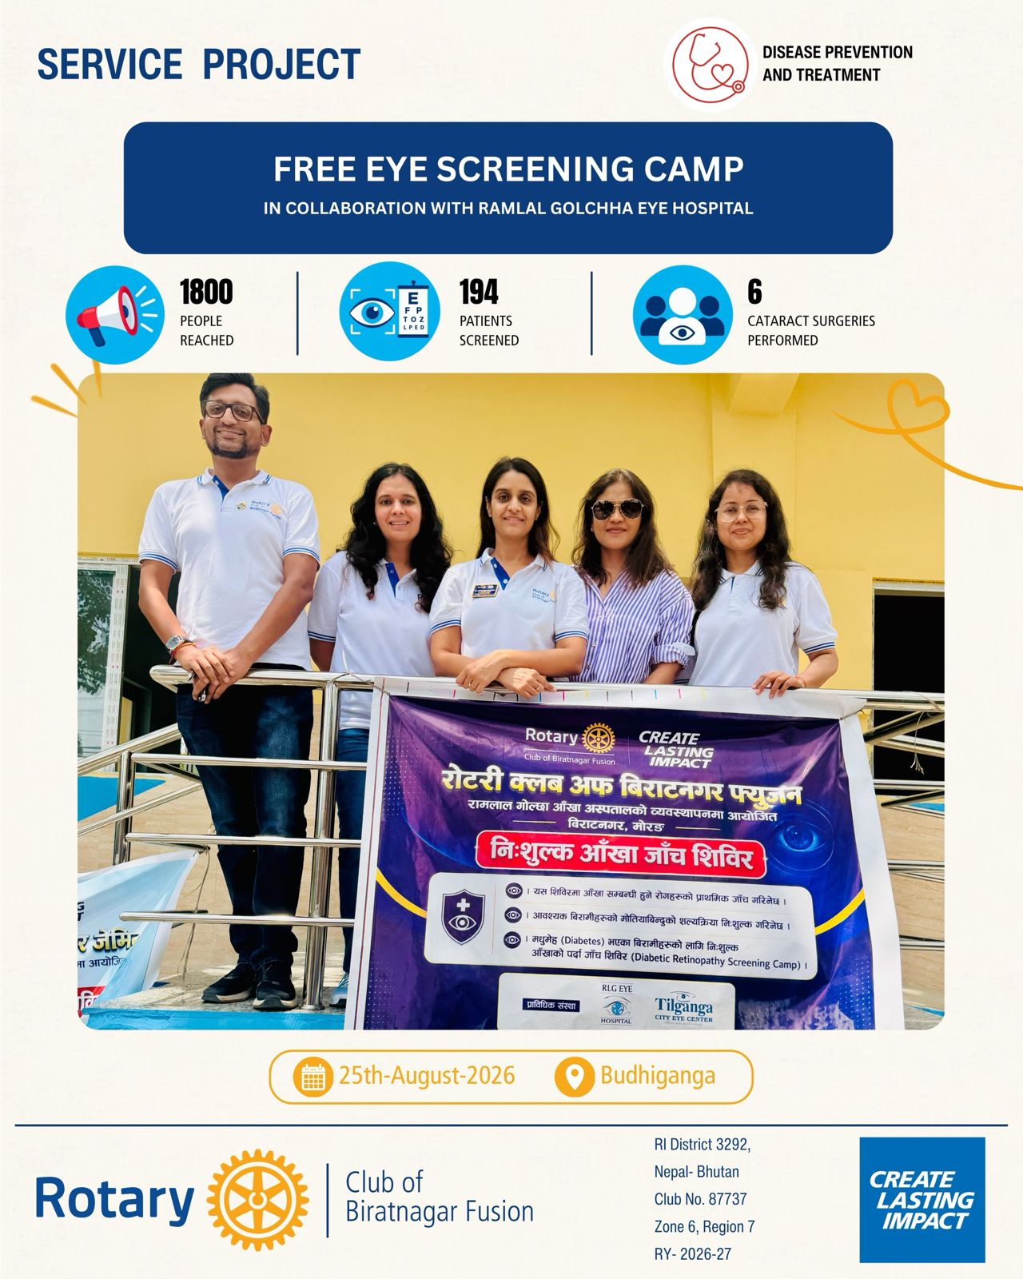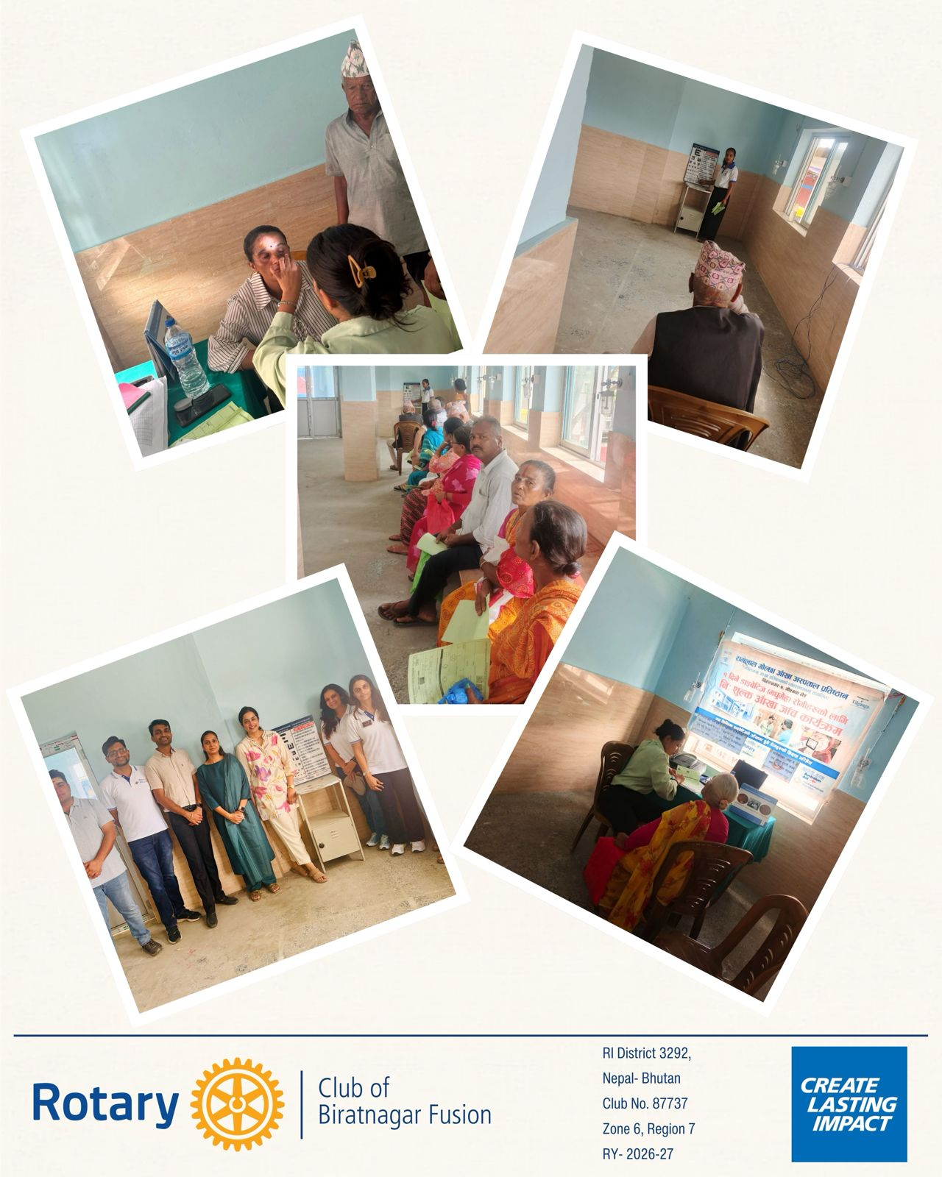

Attended By 5 members

- Shreeja Kabra
- Priyanka Agrawal
- Rohit Agrawal
- Neha Kabra
- Harshita Golecha

