Tree Plantation Program Report
Date: 1 August 2026
Venue: Changunarayan Temple Premises, Bhaktapur (UNESCO World Heritage Site)
The Rotary Club of Bhaktapur successfully organized a Tree Plantation Program on 1 August 2026 at the historic Changunarayan Temple premises, a UNESCO World Heritage Site. The program was conducted as part of the club's commitment to environmental conservation and sustainable community development.
During the event, a total of 750 fruit-bearing and spice plant saplings were planted in collaboration with local stakeholders, Rotarians, Rotaract Club of Bhaktapur , Rotaract Club of KMC Duwakot, Innerwheel Club of Bhaktapur , OIASCA International Nepal Chapter, community members, volunteers, and partner organizations. The plantation included various species that will contribute to biodiversity, environmental sustainability, and the long-term ecological value of the surrounding area.
The program witnessed active participation from Rotary members, local authorities, representatives from collaborating organizations, and community volunteers. The collective effort reflected Rotary's dedication to creating a lasting environmental impact while promoting awareness about the importance of afforestation and conservation.
Submitted by :
Rotary Club of Bhaktapur
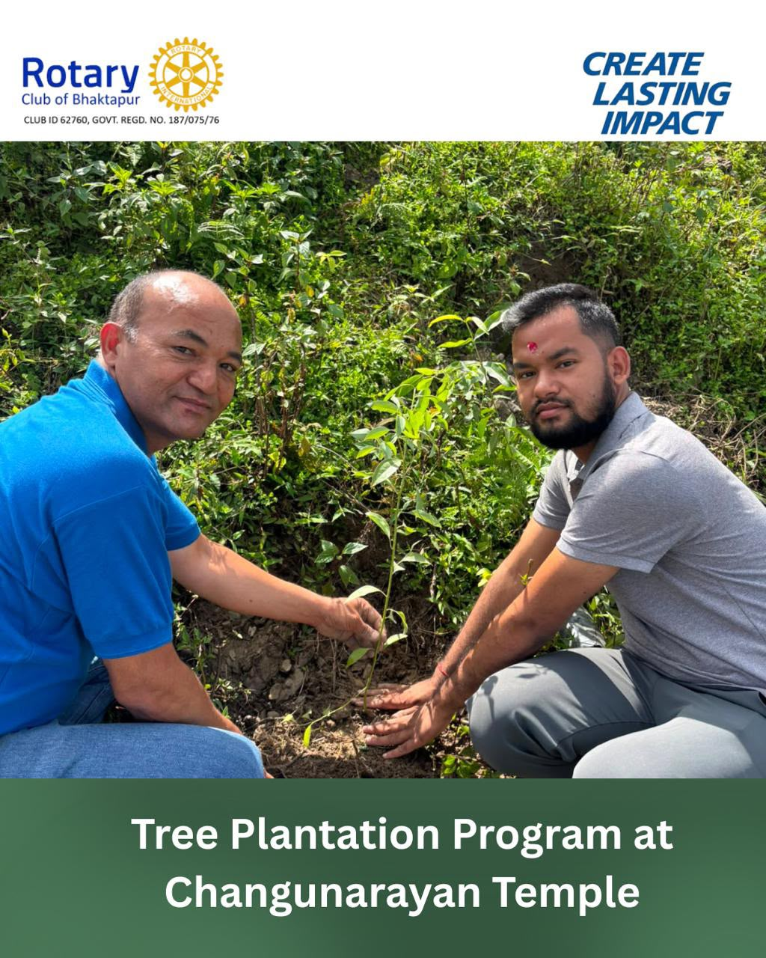
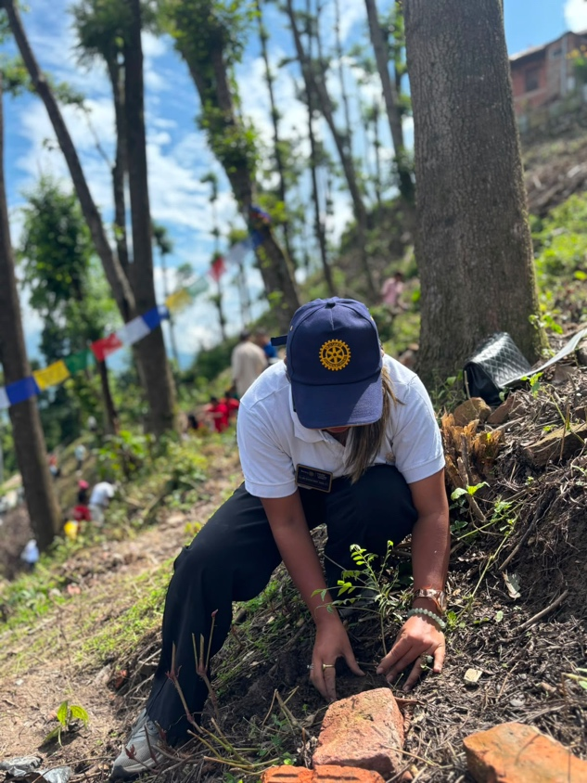
RY 2026/27

