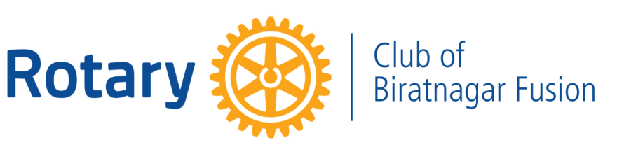

SERVICE PROJECT REPORT

Rasuwa Flood Relief Support

Rotary Year: 2026–27
Date: 2 September 2026
Amount Contributed: NPR 50,000
Contribution Through: RI District 3292

Project Report

Rotary Club of Biratnagar Fusion extended its support towards the Rasuwa Relief Fund by contributing NPR 50,000 through RI District 3292 on 2 September 2026.

The contribution was made as part of the collective Rotary relief effort to assist communities and families requiring support in Rasuwa. Through this initiative, the Club expressed its solidarity with the affected communities and reaffirmed its commitment to humanitarian service during times of need.

Project Summary

Contribution: NPR 50,000
Beneficiaries: Communities requiring relief assistance in Rasuwa
Mode of Support: Financial contribution to the Rasuwa Relief Fund through RI District 3292
Payment Status: Successfully contributed

Prepared by:
Rtn. Aparna Nathani Sharda
Secretary
Rotary Club of Biratnagar Fusion
RY 2026–27



