Menstrual Hygiene Awareness Program & Reusable Sanitary Pad Making Training
( JULY – MATERNAL AND CHILD HEALTH MONTH)

Event Venue | Holding Center ( Kharipati) Bhaktapur
Event Date: | 23rd July 2026
Details | In observance of Rotary's Maternal and Child Health Month, the Rotary Club of Bhaktapur successfully organized a Menstrual Hygiene Awareness Program and Reusable Sanitary Pad Making Training on 23rd July 2026 at the Kharipati Holding Center, Bhaktapur. The program aimed to promote menstrual health awareness, empower women with practical skills, and encourage the use of environmentally friendly and cost-effective reusable sanitary pads.  The program was graced by Chief Guest First Lady Mrs. Niru Karkee, whose presence inspired participants and highlighted the importance of women's health, dignity, and well-being. Participants received practical demonstrations on reusable sanitary pad making and learned about menstrual hygiene management, helping to break stigma and improve health practices.  As part of the initiative, the Rotary Club of Bhaktapur also distributed new clothes to mothers and children, extending care and support to vulnerable families residing at the holding center. The program reflected Rotary's commitment to improving maternal and child health while promoting dignity, self-reliance, and sustainable health practices.  The event was organized in collaboration with Nepal Police, Bhaktapur, and RNA16 Rescue, demonstrating the power of partnership in creating healthier and stronger communities.
Specialty | - Organized in observance of Rotary's Maternal and Child Health Month.  - Conducted menstrual hygiene education and hands-on reusable sanitary pad making training.  - Distributed new clothes to mothers and children living at the holding center.  - Collaborative initiative with Nepal Police, Bhaktapur and RNA16 Rescue.
Facts & Figures | - Date: 23rd July 2026  - Venue: Kharipati Holding Center, Bhaktapur  - Chief Guest: First Lady Mrs. Niru Karkee  - Activities: Menstrual Hygiene Awareness Session, Reusable Sanitary Pad Making Training, Distribution of New Clothes  - Collaborating Organizations: Nepal Police, Bhaktapur & RNA16 Rescue
Budget | - Training Charges  - Reusable Pad Making Materials  - Clothes for Mothers & Children  - Banner & Printing  - Certificates  - Snacks & Drinking Water  - Token of Love for Resource Persons/Guests  Total Budget: NPR 126,760
Beneficiary Profile | Beneficiary Profile  - Women and adolescent girls residing at the Kharipati Holding Center.  - Mothers and children who received new clothes and hygiene education.
Impact/Outcome | - Increased awareness of menstrual hygiene and healthy menstrual practices among women and adolescent girls.  - Equipped participants with practical skills to make reusable sanitary pads, promoting affordability, sustainability, and self-reliance.  - Improved the well-being and dignity of mothers and children through the distribution of new clothing.  - Strengthened collaboration between the Rotary Club of Bhaktapur, Nepal Police, and RNA16 Rescue in advancing maternal and child health and community welfare.

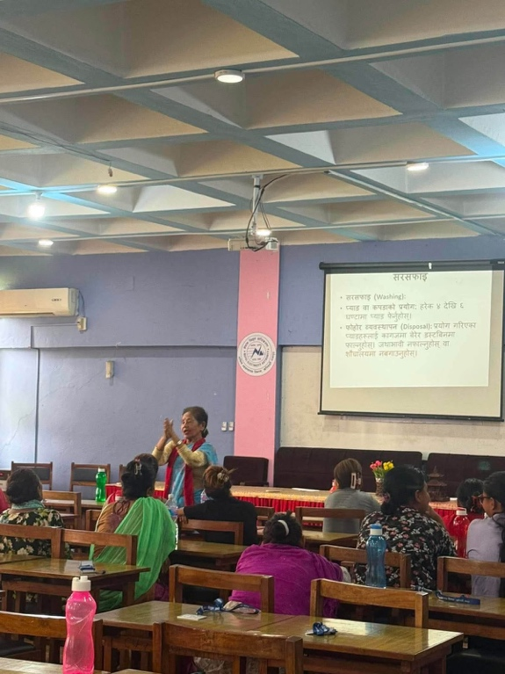
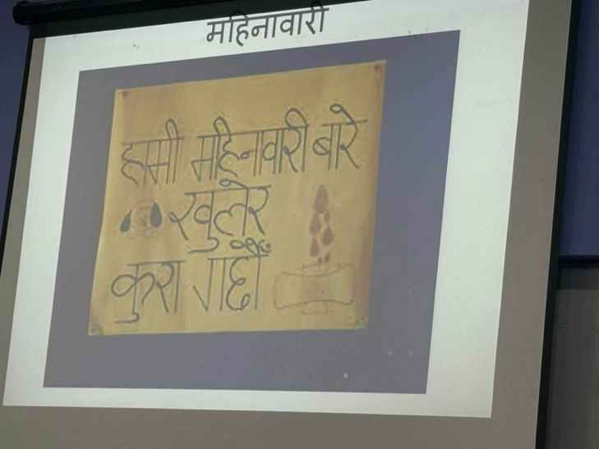
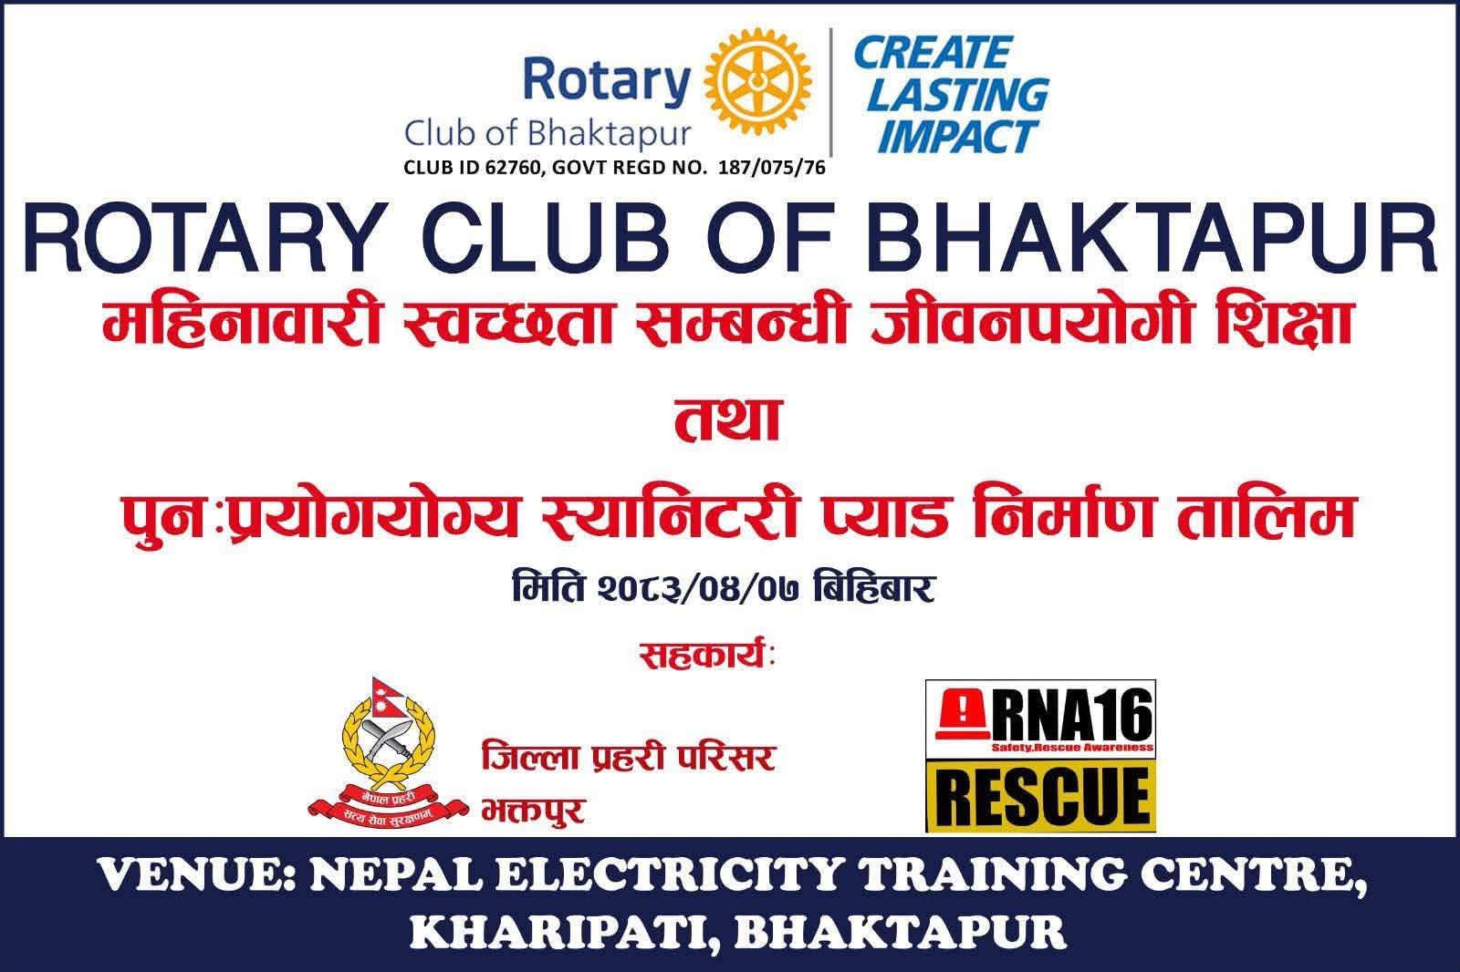
Kindly find the pictures below:
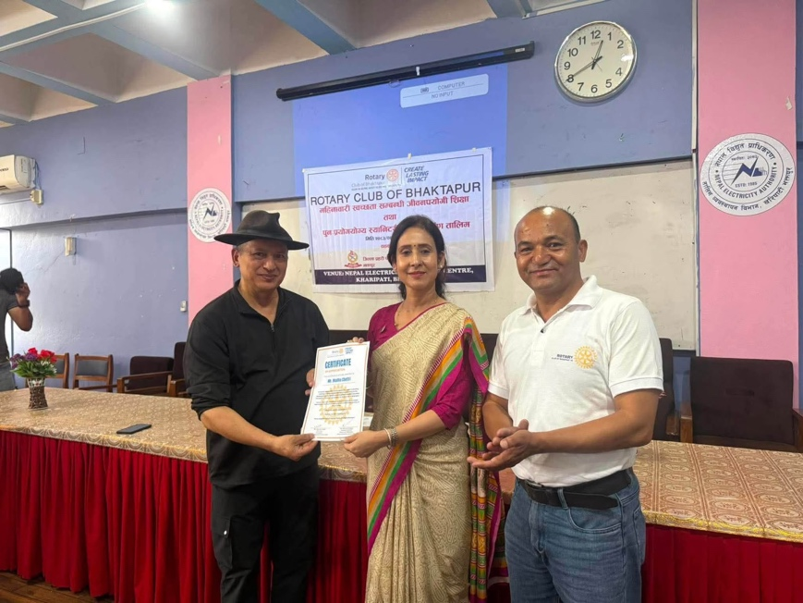

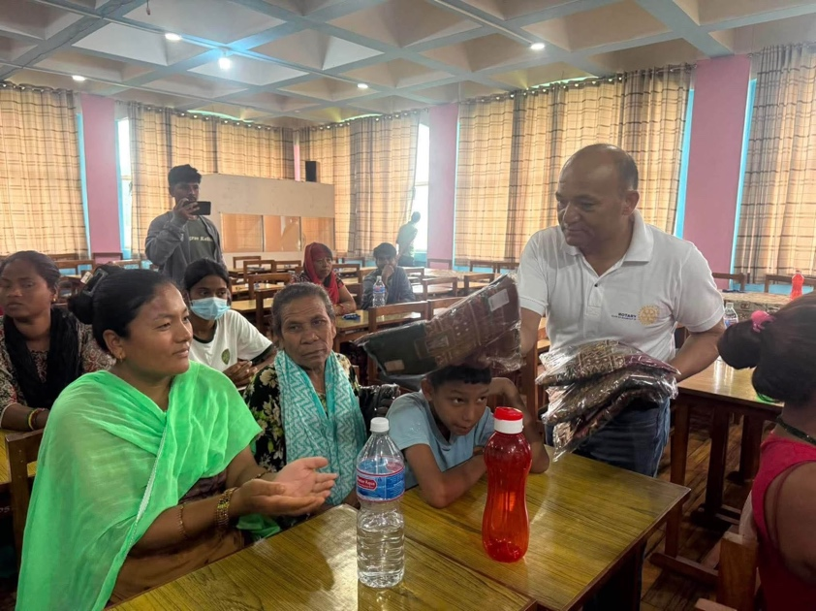

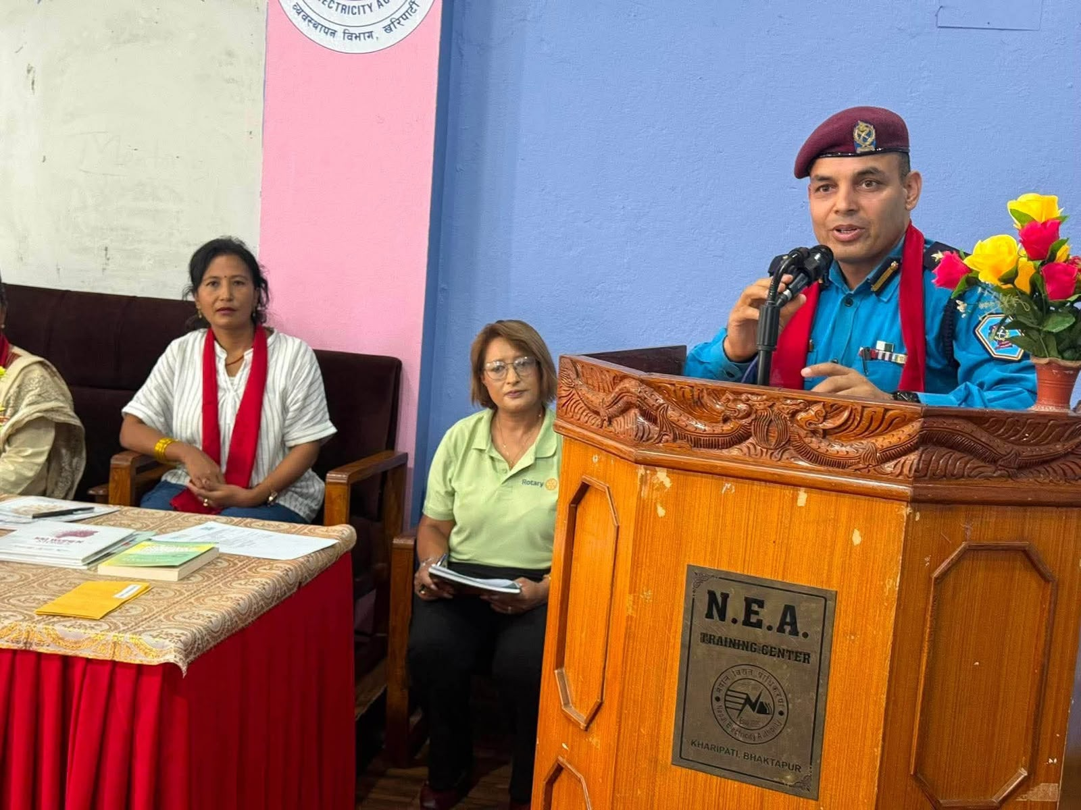

Submitted by :
Rtn. Dasrath Prajapati Rtn. Priyanka Chaguthi
President RY 2026/27 Secretary RY 2026/27

