Wheelchair Distribution Program on the Occasion of the 23rd Installation Ceremony
Event Venue | Hotel Dachi, Bhaktapur
Event Date: | 4th July 2026
Details | The Rotary Club of Bhaktapur organized a Wheelchair Distribution Program on 4th July 2026 at Hotel Dachi, Bhaktapur as a meaningful service project during its 23rd Installation Ceremony. In line with Rotary International's 2026–27 theme, "Create Lasting Impact," the club distributed four wheelchairs to individuals with physical disabilities to improve their mobility, independence, and quality of life.  The beneficiaries represented different parts of Nepal and came from diverse vocational backgrounds. The wheelchairs were provided to support their daily activities, livelihoods, and social participation. By prioritizing service over celebration, the club demonstrated its commitment to making a tangible difference in the lives of those in need. The beneficiaries and their families expressed their sincere appreciation for the support, which will enable them to move more freely and perform their daily tasks with greater dignity and confidence.  This initiative reflects the Rotary Club of Bhaktapur's continued dedication to humanitarian service and inclusive community development through impactful projects.
Specialty | - Service project conducted as part of the 23rd Installation Ceremony.  - Improved mobility and independence for persons with disabilities.  - Supported beneficiaries from different regions and occupational backgrounds.
Facts & Figures | - Wheelchairs Distributed: 4  - Date: 4th July 2026  - Venue: Hotel Dachi, Bhaktapur  - Organized by: Rotary Club of Bhaktapur
Budget | - Cost per Wheelchair: NPR 5,000  - Total Budget: NPR 20,000
Beneficiary Profile | - Dipak Shrestha – Tattoo Artist, Budhanilkantha  - Harish Singh Bista – Home-based Advanced Tailor, Baitadi  - Shanti Kumari Waiba – Basic Tailoring Trainee, Kupandol  - Sunita Chaudhary – Basic Tailoring Trainee, Dang
Impact/Outcome | - Four individuals with mobility challenges received wheelchairs, enabling greater independence and easier access to work and daily activities.  - The project enhanced the beneficiaries' dignity, confidence, and quality of life while reducing the physical burden on their families and caregivers.  - The initiative reinforced Rotary Club of Bhaktapur's commitment to inclusive service and creating a lasting impact in the community.

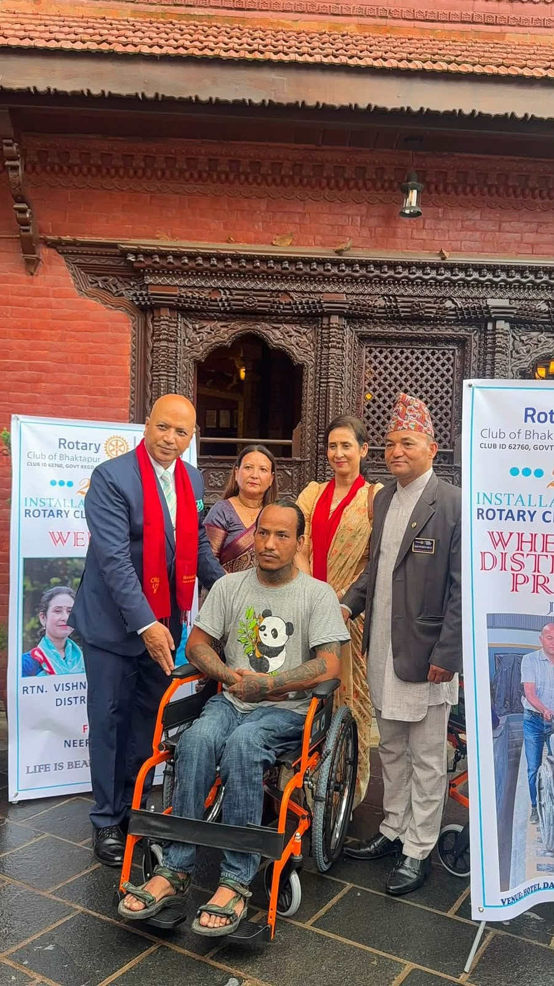
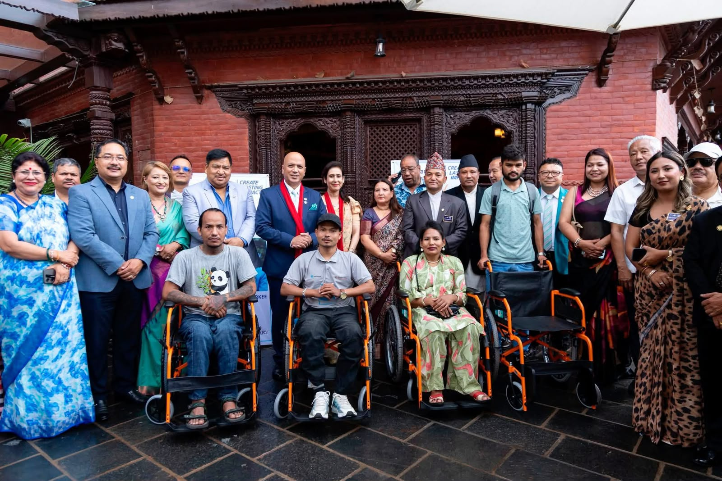
Pictures:

