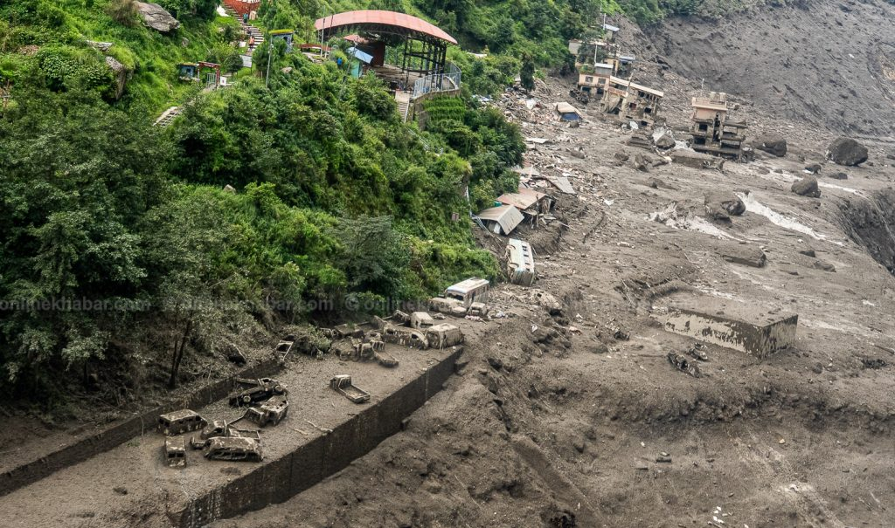
Bhotekoshi Flood Rescue and Relief Project

Event Venue | Different Places
Event Date: | 27th August, 1st September, 4th September
Details | In response to the devastating Bhotekoshi flood, the Rotary Club of Bhaktapur mobilized and coordinated an emergency rescue and relief initiative to provide immediate humanitarian support to the flood-affected communities and assist ongoing rescue and recovery efforts.  As part of the emergency response, a total of 1,016 dead body bags were managed and distributed to address the critical requirement for the safe and dignified handling of victims during the disaster. Among these, 400 dead body bags were supported by Rotary District 3292, while 316 dead body bags were supported by Rotary Club of Kasthamandap. The remaining body bags were mobilized through other relief resources as part of the emergency response.  The relief initiative also included the distribution of essential grocery items worth NPR 295,000 to support families affected by the flood. In addition, 1,000 brand-new shirts were provided to affected individuals, helping address their immediate clothing needs and restore dignity during the difficult circumstances following the disaster.  The project demonstrated Rotary's commitment to Disaster Response and Humanitarian Service, highlighting the importance of timely action, resource mobilization, and collaboration among Rotary clubs and the wider community during a humanitarian emergency.
Specialty | Emergency rescue and relief response following the Bhotekoshi flood.  • Managed and distributed 1,016 dead body bags for critical disaster-response requirements.  • 400 dead body bags supported by Rotary District 3292.  • 316 dead body bags supported by Rotary Club of Kasthamandap.  • Distributed essential grocery and food items worth NPR 295,000/  • Distributed 1,000 brand-new shirts to flood-affected individuals.  • Mobilized resources through collaboration within the Rotary network.  • Provided timely humanitarian assistance during a critical disaster situation.
Facts & Figures | Disaster: Bhotekoshi Flood  • Total Dead Body Bags Managed & Distributed: 1,016  • Supported by Rotary District 3292: 400 body bags  • Supported by Rotary Club of Kasthamandap: 316 body bags  • Grocery / Essential Food Relief: NPR 295,000  • Brand-New Shirts Distributed: 1,000 pieces  • Dead Body Bag Cost: 1,016 × NPR 950 = NPR 965,200  • Brand-New Shirt Cost: 1,000 × NPR 750 = NPR 750,000  • Total Project Value: NPR 2,010,200  • Project Focus: Emergency Rescue, Relief & Disaster Response.
Budget
  Particulars | Quantity / Value | Amount
  Dead Body Bags | 1,016 × NPR 950 | NPR 965,200
  Grocery / Essential Food Items | — | NPR 295,000
  Brand-New Shirts | 1,000 × NPR 750 | NPR 750,000
  Total Project Value |  | = NPR 2,010,200
Beneficiary Profile | - Individuals and families affected by the Bhotekoshi flood.  • Vulnerable families requiring essential food and clothing support.  • Rescue and recovery efforts requiring critical disaster-response materials.  • Communities directly impacted by the flood and its aftermath.  .
Impact/Outcome | • Addressed an urgent and critical disaster-response requirement through the management and distribution of 1,016 dead body bags.  • Supported the safe and dignified handling of victims during rescue and recovery operations.  • Strengthened emergency response through support from Rotary District 3292 and Rotary Club of Kasthamandap.  • Provided NPR 295,000 worth of essential grocery and food supplies to affected communities.  • Distributed 1,000 brand-new shirts, helping meet the immediate clothing needs of flood-affected individuals.  • Provided timely humanitarian assistance to vulnerable families during a critical period.  • Demonstrated effective resource mobilization and collaboration within the Rotary network.  • Reinforced the Rotary Club of Bhaktapur's commitment to disaster response, humanitarian service, and community resilience.

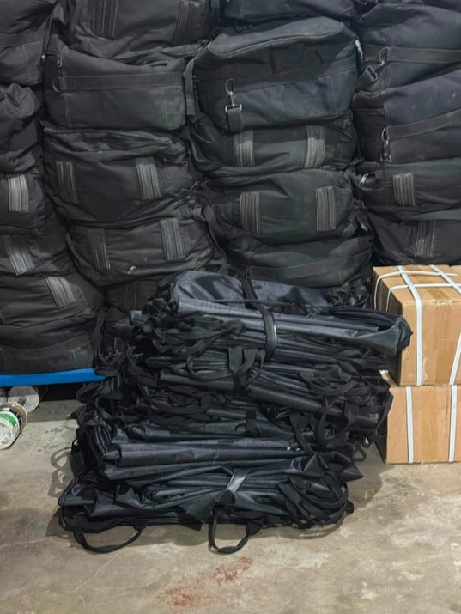
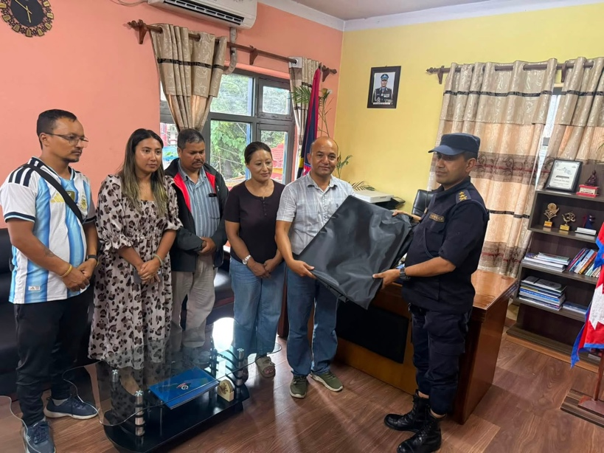
Kindly find the pictures below:

1st Phase - First 100 Dead Bag Distribution to District Police Office.

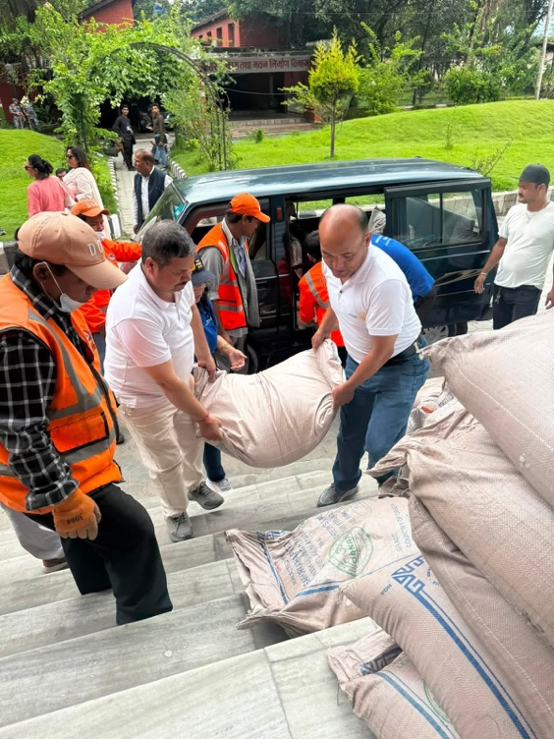
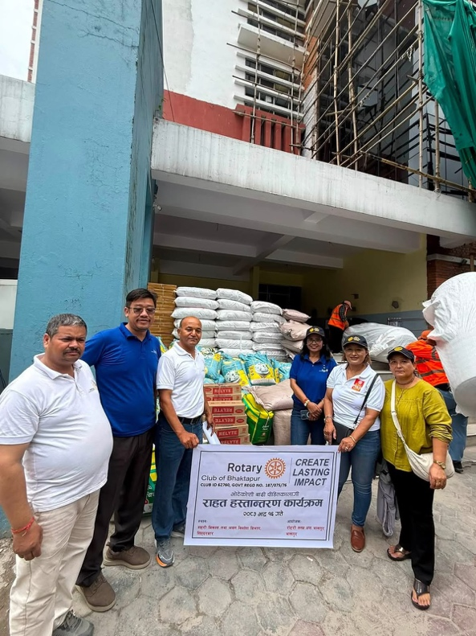

2nd Phase: Relief Material (Groceries Distribution )
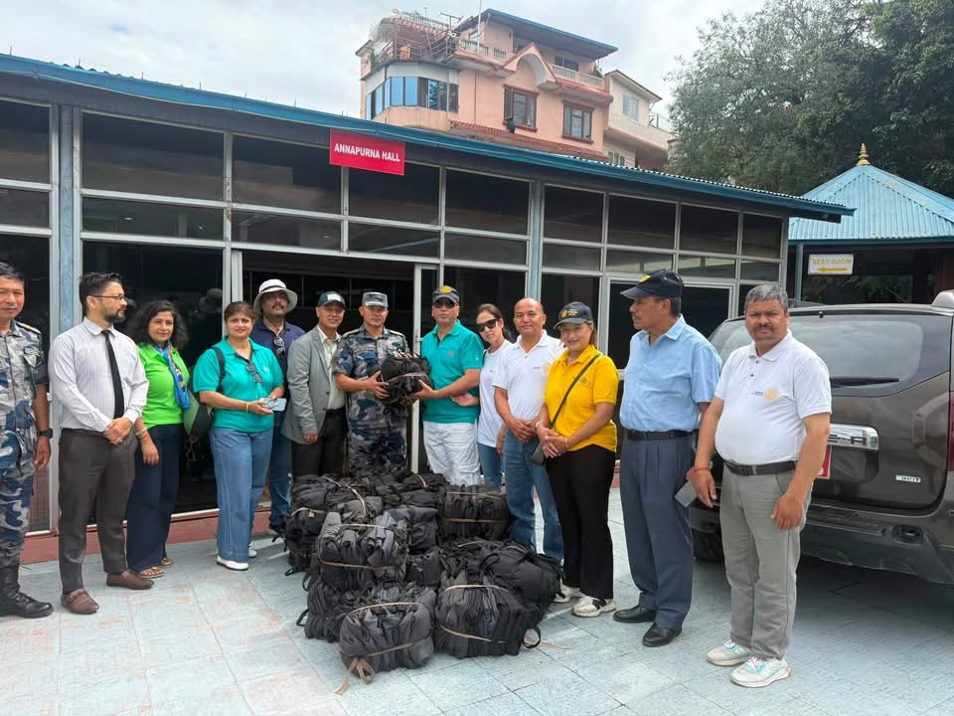

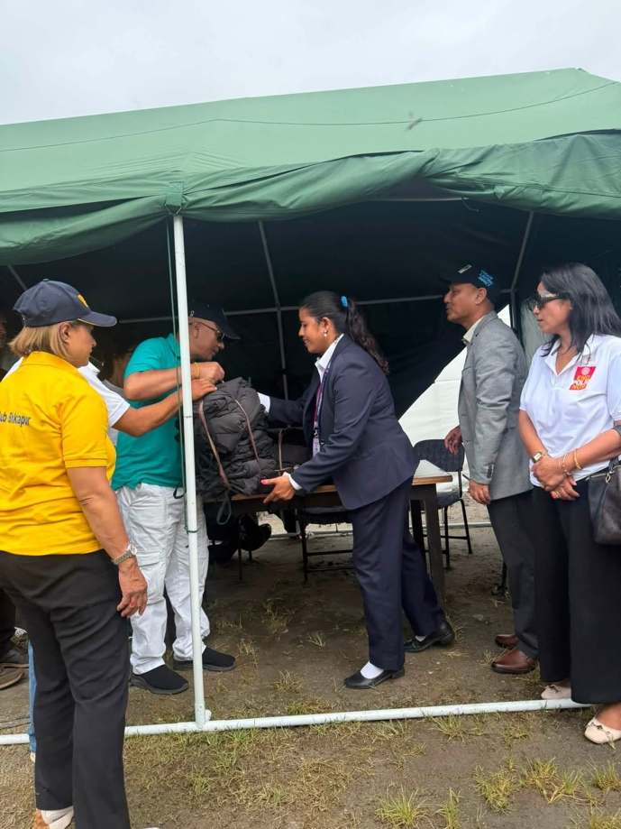
3rd Phase – 400 Dead Body Bag (Supported by Rotary District 3292 and 316 Dead Body Bag by RC Kasthamandap.

Submitted by:
Rtn. Dasrath Prajapati Rtn. Priyanka Chaguthi
President RY 2026/27 Secretary RY 2026/27

