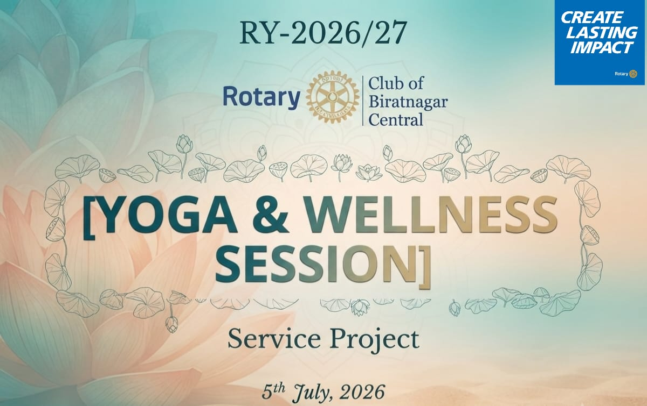
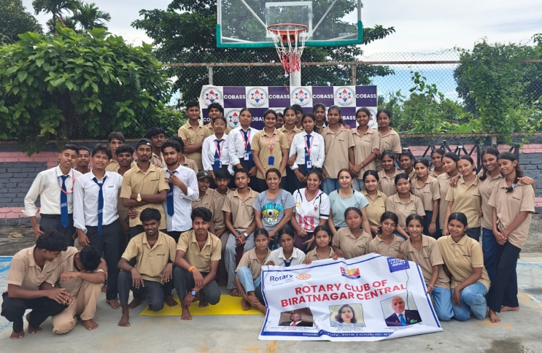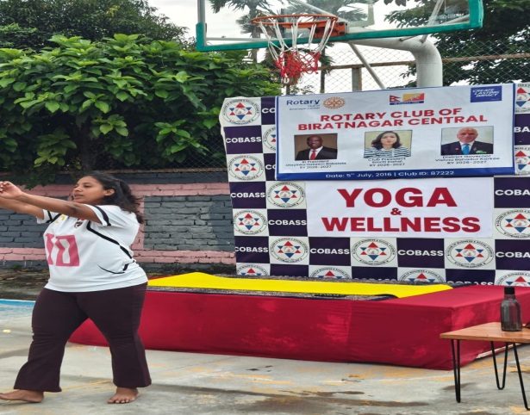

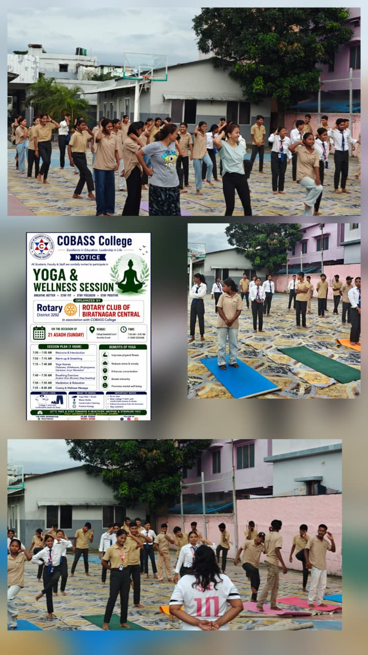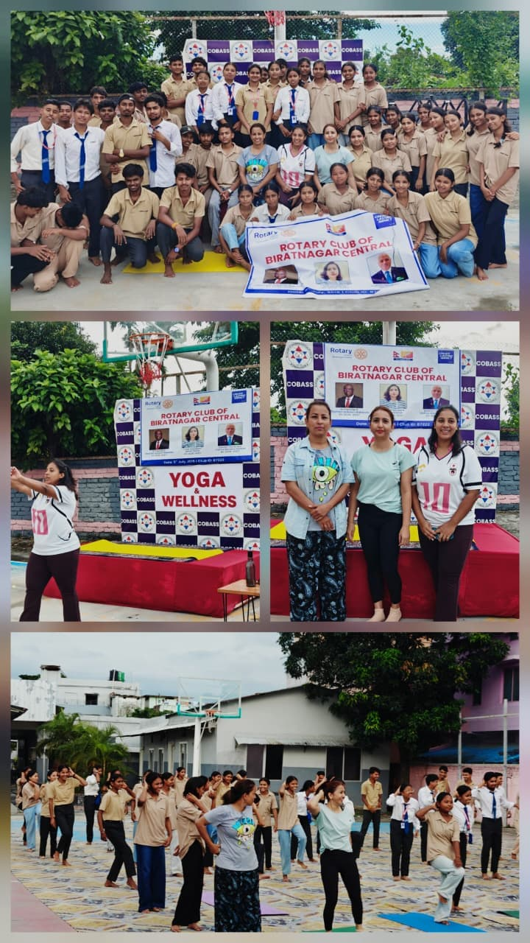
On July 05,2026, The Rotary Club of Biratnagar Central, successfully organized a rejuvenating "Yoga and Wellness Session" in collaboration with COBASS College, designed to inspire students, as well as members to "Breathe Better, Stay Fit, Stay Focused and Positive" where over 50 students, college faculty and club members were benifited.

